Forecasting Daily Traffic Incidents on Pasig City's Major Roads – Case Study Documentation
Group1: Bahillo, Flores, Olmillo, & Ruflo · Course: IT 201 – Platform Technologies

Chapter 1 – Problem Identification and Data Requirements
Pasig City's three busiest roads (C5, Ortigas Avenue and Marcos Highway) averaged 0.87 MMDA-reported traffic incidents per road per day between August 2018 and February 2020, with C5 alone averaging 1.64. Traffic managers have no day-ahead estimate of how many incidents to expect on each road, so this project builds one.

1.1 The problem
Vehicular accidents, collisions, stalled vehicles and road works block lanes and slow traffic on Pasig's major roads. Enforcers and tow trucks are placed where incidents are expected, but the expected number is a judgement call, not a forecast. The project falls under the case study's suggested problem area "Pasig City traffic conditions".
Validation of the problem: To validate the problem, the group reviewed published reports (preliminary research). MMDA's Metro Manila Accident Recording and Analysis System (MMARAS) recorded 121,771 road crashes in Metro Manila in 2019, about 334 a day, with 394 deaths (Top Gear Philippines, 2020). The same MMARAS data showed C5 as Metro Manila's deadliest road for the third year running, with 31 fatalities, 1,136 non-fatal injuries and 7,568 property-damage cases in 2019 (Chua, 2020). The project's own dataset shows that MMDA reported 1,611 incidents on C5, Ortigas Avenue and Marcos Highway within Pasig City over about 18 months (August 2018 to February 2020). MMARAS counts crashes while the dataset counts incidents that MMDA tweeted, so the two are not the same measure, but both show that incidents on these roads are frequent and well documented. News reports on MMDA data also show that most Metro Manila road crashes in 2024 took place on EDSA and C5 (Sigales, 2025), and that traffic cost the Philippines about P3.5 billion per day in 2018 (Wheels.ph, 2019). Because enforcers and tow trucks are limited, knowing how many incidents to expect on each road and day is a practical planning question.

1.2 Who is affected and why it matters
Commuters, motorists and public transport riders lose time when an incident blocks a lane, and they face risk at the incident site. Residents and businesses along the roads are affected by the congestion that incidents cause. MMDA and Pasig City traffic management personnel decide where to send limited enforcers and tow trucks, so they are the direct users of any forecast.
Relevance to Pasig City and PLP: C5, Ortigas Avenue and Marcos Highway are major roads that serve Pasig City, and 1,723 of the dataset's 17,312 rows (10%) are incidents that MMDA placed in Pasig City. The results are meant for the Pasig City traffic management office and the MMDA personnel who cover Pasig, and they also matter to Pasig commuters, including PLP students and staff who travel on these roads.
The data shows the pressure is uneven: half of all road-days have no reported incident, while C5 regularly has two or more. Knowing which road and which days are likely to be busy lets scarce units go where they are needed.

1.3 Objectives and research questions
General objective: To develop and evaluate a regression model that predicts the number of MMDA-reported incidents per day on each of three major roads in Pasig City.
Specific objectives
The specific objectives are to prepare a clean road-day dataset from public MMDA traffic alerts; to explore how incidents vary by road, day of week and hour; to train regression models and compare them against a simple per-road average; and to assess whether the best model is useful for planning and state its limits.
Research questions
The study asks four research questions.
- How do reported incident counts differ by major road and by day of week?
- Does recent activity, measured over the previous 7 days, help predict today's count?
- Does a regression model predict daily counts more accurately than a per-road average?
- Is the model accurate enough to support planning, and where does it fall short?

1.4 Data needed
Data | Used for
Date of each incident | Build daily counts, day of week, month and recent-activity features
Location name | Assign each incident to C5, Ortigas Avenue or Marcos Highway
Time | Hour-of-day analysis
Incident type, lanes blocked, vehicles involved | Describing the incidents (not used by the model)
Tweet URL | Tracing each record to its original alert
The data must cover enough days to learn weekly patterns and to test on later days than those used for training.

1.5 Machine learning task and algorithm
Task: regression. The target is the number of incidents on a road in a day (0, 1, 2, ...).
Algorithms: Linear Regression, Poisson Regression and Random Forest Regressor, each compared with two baselines that predict every road's average (mean) or median count. Chapter 5 explains why each is appropriate.

1.6 How the results could be used
The predicted counts could help the MMDA and Pasig City's traffic management office plan the weekly placement of enforcers and tow trucks, for example by sending more units to the roads and days expected to be busiest. The model is a planning aid, not an automated decision-maker; Chapter 7 discusses its limits.

Chapter 2 – Data Gathering
The project uses a public dataset of MMDA traffic alerts for Metro Manila (17,312 rows, 20 Aug 2018 to 27 Dec 2020), of which 1,723 rows are for Pasig City. The original file was kept unchanged as the raw dataset.

2.1 Source and method
The project uses a publicly available dataset with a documented source, which is one of the options Phase II allows. The dataset is Manila Traffic Incident Data: Incidents Reported by the Metro Manila Development Authority Twitter Page, shared on Kaggle by Panji Brotoisworo under the CC BY-NC-SA 4.0 license (https://www.kaggle.com/datasets/esparko/mmda-traffic-incident-data). The file used is data_mmda_traffic_spatial.csv.
The original source is the MMDA ALERT tweets on the MMDA Twitter page. According to the dataset's description, the author collected them through the Twitter API and parsed the tweet text with a Python script (https://github.com/pbrotosworo/tweet2map). The data starts on 20 August 2018 because of the author's free-tier API access, and there is a gap in early 2020 caused by pandemic-related difficulties and a code upgrade. The author notes that the dataset does not represent all incidents in Metro Manila: the MMDA's jurisdiction is mainly the national roads, so the data is biased toward roads such as EDSA and C5. The author is an independent researcher with no affiliation with the MMDA. Every record links to its tweet in the Source column.

2.2 Raw dataset preservation
The raw file is stored unchanged. All cleaning is done in memory in the notebook, so the original can always be re-checked.

2.3 Structure of the raw data
The file has 17,312 rows and 13 columns.
Column | Type | Meaning
Date | Text (YYYY-MM-DD) | Date of the alert
Time | Text | Time of the alert, for example "7:55 AM"
City | Text | City where MMDA placed the incident
Location | Text | Road segment or landmark named in the alert
Latitude, Longitude | Decimal number | Geocoded position of the location
High_Accuracy | 0 or 1 | 1 if the geocoding is precise
Direction | Text | NB, SB, EB or WB
Type | Text | Incident type, for example vehicular accident or stalled vehicle
Lanes_Blocked | Number | Number of lanes occupied
Involved | Text | Vehicles involved
Tweet | Text | Alert text
Source | Text (URL) | Link to the original tweet

2.4 Scope and sufficiency
Stage | Rows
Raw file, all of Metro Manila | 17,312
Rows where City is Pasig City | 1,723 (10%)
Incidents on the three major roads, after cleaning | 1,611
Road-day rows used for modeling | 1,656
The guideline of at least 100 usable records is met at every stage.

2.5 Data quality at collection
In the 1,723 Pasig rows, Time is missing in 8 rows, Direction in 46, Type in 5, Lanes Blocked in 49 and Involved in 40. Across the whole file, 187 rows have no City. There are 242 different spellings of location and 111 incident type labels, so they must be grouped (Chapter 3).

2.6 Privacy and consent
The records are public posts by a government agency. They contain no names, plate numbers or other personal details, only vehicle types and places, so no individual consent is needed. The source is cited, and the dataset's license (CC BY-NC-SA 4.0) allows non-commercial use with attribution, which fits coursework. Any derived dataset that is shared should carry the same license. No personal or sensitive data was added.

Chapter 3 – Data Preparation
The 17,312 raw rows became an engineered dataset of 1,656 rows and 8 columns, one row per major road per day, saved as engineered_pasig_major_road_day.csv. Each step below says what was done, why, and how many rows remained.

3.1 Steps, treatment and justification
Step | What was done | Why | Rows after
1. Filter | Kept rows where City is Pasig City | The study is about Pasig | 1,723
2. Dates | Converted Date from text to a date type | Needed for day-of-week, month and lag features | 1,723
3. Hour | Read the hour from Time; where unusable (10 rows), recovered it from the alert text in 3 rows | Hour is only used for one exploratory chart, so the 7 unrecoverable rows were kept | 1,723
4. Duplicates | Removed 3 repeated tweets (same URL) and 35 cases of the same incident tweeted twice (same date, time, location, direction and type) | Avoid counting one incident twice | 1,685
5. Major roads | Grouped 242 location spellings into C5, Ortigas and Marcos Highway; excluded 74 rows (EDSA, Meralco Onyx, ADB, Poveda and others) | Daily counts need enough incidents per group; the other locations are too scattered | 1,611
6. Validation | Checked ranges and categories (see 3.2) | Catch invalid values | 1,611
7. Period | Kept dates up to 29 Feb 2020 | Counts fall sharply from March 2020 (about 90 incidents in Feb 2020, 29 in Mar, 1 in Apr); the dataset's author reports a collection gap in early 2020, and traffic also fell during the lockdown | –
8. Aggregate | Counted incidents per major road per day and added zero-incident days | The file lists only days with at least one incident | 1,677
9. Features | Added day of week, month, weekend flag, the count 7 days earlier and the average of the previous 7 days | Capture weekly and recent-activity patterns | 1,677
10. Lag rows | Dropped the first 7 days, which have no history | Lag features need 7 earlier days | 1,656
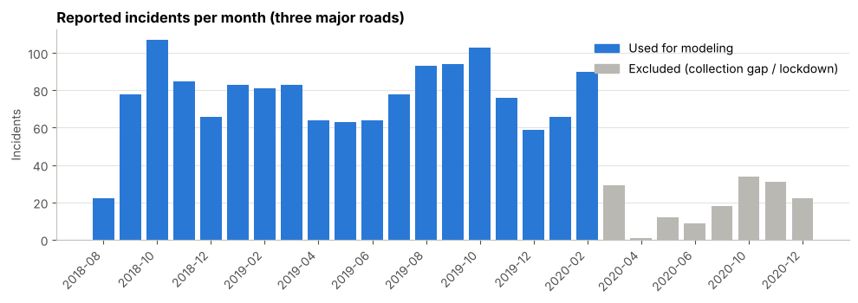
Figure 3.1 – Reported incidents per month. Months after February 2020 (grey) are excluded from modeling.

3.2 Validation of ranges, units, dates and categories
All checks on the 1,611 incidents passed: latitude within 14.50 to 14.66 and longitude within 121.03 to 121.13 (the Pasig area); High_Accuracy is 0 or 1; Direction is NB, SB, EB or WB when present; Lanes_Blocked is between 1 and 6 when present; hours are between 0 and 23; dates fall between Aug 2018 and Dec 2020. Column names were already consistent, so no renaming was needed.

3.3 Missing values
Hour (7 rows), Direction (37), Type (5), Lanes_Blocked (42) and Involved (39) are missing in the 1,611 incidents. These are descriptive columns that the model does not use, so they were not imputed and the rows were kept.
Days with no row in the file are treated as days with no reported incident. This is an assumption, because a day could also be missing when MMDA posted nothing, and the data cannot tell the two apart.

3.4 Outliers
The highest counts are 7 incidents (C5 on 16 Jan 2019 and 19 Feb 2019) and 6 incidents on 7 other days, all on C5. They are plausible busy days, not errors, so they were kept. Across all road-days the mean is 0.87 and the maximum is 7.

3.5 Derived variables
Variable | Meaning | Used by the model
DayOfWeek | 0 = Monday to 6 = Sunday | Yes
Month | 1 to 12 | Yes
IsWeekend | 1 on Saturday or Sunday | No (duplicates DayOfWeek; saved for reference)
Incidents_Lag7 | Count on the same road 7 days earlier | Yes
Incidents_Roll7 | Average count on the same road over the previous 7 days, excluding today | Yes

3.6 Encoding and scaling
Major road (3 values), day of week (7) and month (12) are one-hot encoded into 22 columns. The two lag features are standardized (mean 0, standard deviation 1). Together with the 2 scaled features this gives 24 model inputs. Both steps are fitted on the training period only and are re-fitted inside every cross-validation fold, so nothing from the test period leaks into training.

3.7 Resulting dataset
Dataset | Rows | Columns
Raw file | 17,312 | 13
Pasig City rows | 1,723 | 13
Engineered dataset | 1,656 | 8
The engineered columns are Date, MajorRoad, DayOfWeek, Month, IsWeekend, Incidents_Lag7, Incidents_Roll7 and Incidents (the target). It covers 27 Aug 2018 to 29 Feb 2020: 552 days for each of the 3 roads, with no missing values.

Chapter 4 – Exploratory Data Analysis
Half of all road-days (843 of 1,656) have no reported incident, C5 averages 1.64 incidents a day against 0.54 and 0.43 on the other two roads, and weekdays are busier than weekends. These patterns are the basis for the model's features.

4.1 First and last five rows of the engineered dataset
Date | MajorRoad | DayOfWeek | Month | IsWeekend | Incidents_Lag7 | Incidents_Roll7 | Incidents
2018-08-27 | C5 | 0 | 8 | 0 | 2 | 0.857 | 0
2018-08-27 | MARCOS | 0 | 8 | 0 | 0 | 0.286 | 1
2018-08-27 | ORTIGAS | 0 | 8 | 0 | 1 | 0.429 | 1
2018-08-28 | C5 | 1 | 8 | 0 | 0 | 0.571 | 3
2018-08-28 | MARCOS | 1 | 8 | 0 | 1 | 0.429 | 0
... | ... | ... | ... | ... | ... | ... | ...
2020-02-28 | MARCOS | 4 | 2 | 0 | 0 | 0.143 | 1
2020-02-28 | ORTIGAS | 4 | 2 | 0 | 0 | 0.000 | 2
2020-02-29 | C5 | 5 | 2 | 1 | 0 | 1.857 | 2
2020-02-29 | MARCOS | 5 | 2 | 1 | 0 | 0.286 | 1
2020-02-29 | ORTIGAS | 5 | 2 | 1 | 0 | 0.286 | 1

4.2 Descriptive statistics
Variable | Mean | Std | Min | 25% | 50% | 75% | Max
Incidents (target) | 0.872 | 1.170 | 0 | 0 | 0 | 1 | 7
Incidents_Lag7 | 0.866 | 1.167 | 0 | 0 | 0 | 1 | 7
Incidents_Roll7 | 0.866 | 0.702 | 0 | 0.429 | 0.571 | 1.143 | 3.429

4.3 Distribution of the target and frequency of categories
Incidents in a road-day | Road-days | Share
0 | 843 | 50.9%
1 | 436 | 26.3%
2 | 229 | 13.8%
3 | 78 | 4.7%
4 or more | 70 | 4.2%
The target is right-skewed: most road-days have 0 or 1 incident and a few have up to 7. Each of the three roads has 552 road-days, so the categories are balanced by construction.

4.4 Visualizations
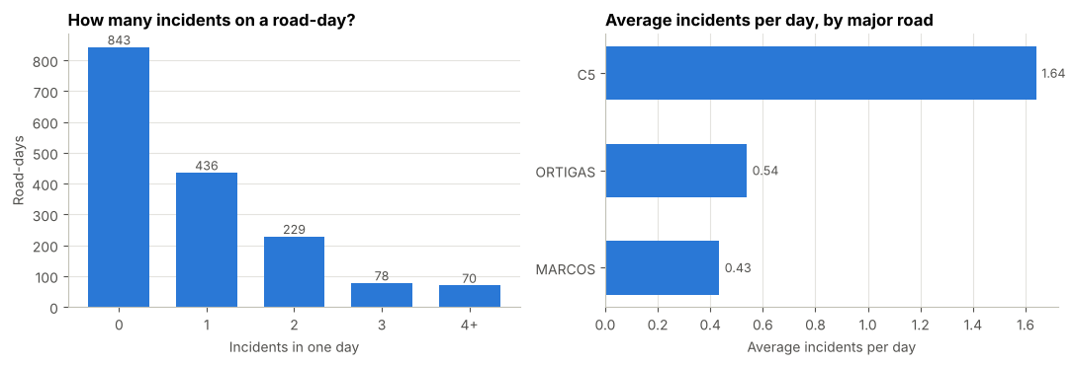
Figure 4.1 – Distribution of daily incidents (left) and average incidents per day by major road (right).
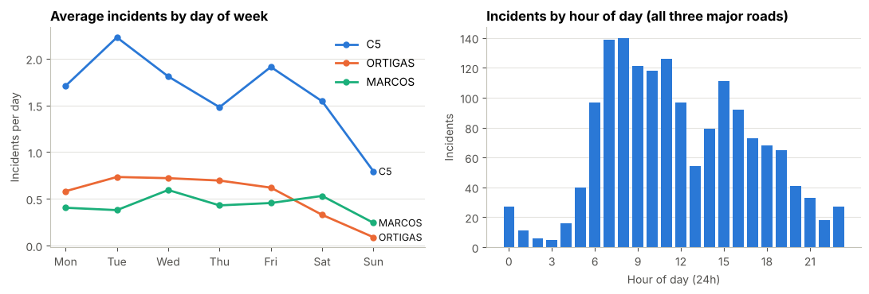
Figure 4.2 – Day-of-week pattern for each road (left) and incidents by hour of day across the three roads (right).
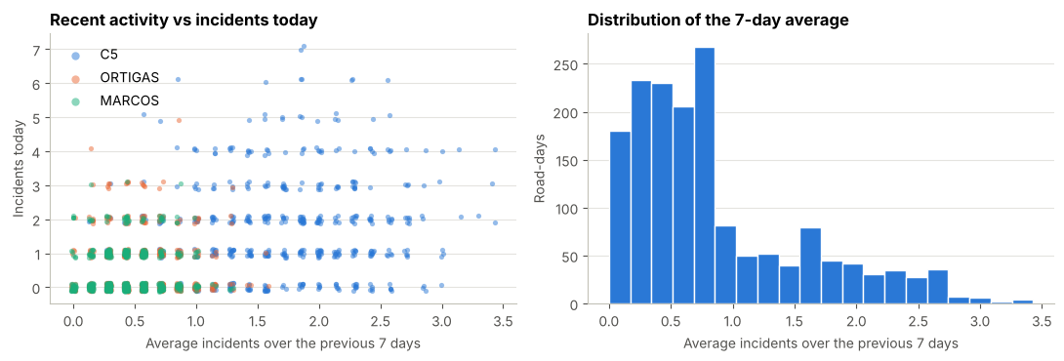
Figure 4.3 – Recent activity against incidents today, by road (left) and distribution of the 7-day average (right).
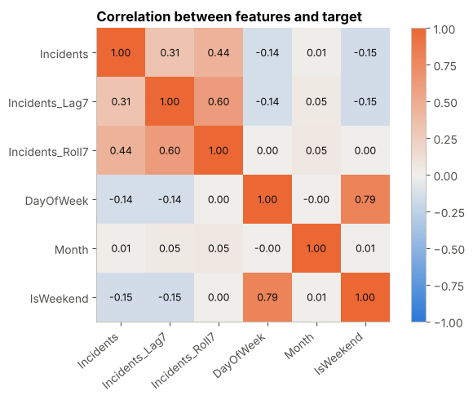
Figure 4.4 – Correlation between the numeric features and the target.

4.5 Findings and their relevance
The major road matters most. C5 averages 1.64 incidents per day, against 0.54 on Ortigas and 0.43 on Marcos Highway. This is relevant because the road is the strongest predictor, and the per-road average is the natural baseline to beat.
Weekdays are busier than weekends. C5 peaks on Tuesdays (about 2.2) and falls to about 0.8 on Sundays, while Ortigas drops to almost zero on Sundays. Day of week correlates weakly and negatively with the target (-0.14), and it is used as a model feature.
Incidents cluster in the morning. Reports rise sharply from 6 am and stay at roughly 120 to 140 per hour around 7 to 11 am, dip around 1 pm and rise again around 3 pm. The model predicts daily totals, but this pattern shows that the morning rush is where deployment matters most.
Recent activity is a weak signal on its own. The 7-day average (0.44) and the count 7 days earlier (0.31) correlate positively with today's count, but the scatter plot shows that this mostly reflects which road it is: C5 points sit at higher averages (about 1 to 3.4), while Ortigas and Marcos cluster below about 1. The lag features therefore help only a little beyond the road effect.
Month shows almost no relationship with the target (correlation 0.01), so seasonality is weak in this 18-month period.

Chapter 5 – Machine Learning Model Development
Three regression models were trained on 1,200 road-days (27 Aug 2018 to 30 Sep 2019) and compared with two baselines that predict each road's average (mean) or median count. Linear Regression had the lowest cross-validation RMSE and was selected as the main model.

5.1 Why regression, and why these algorithms
The target is a count (0, 1, 2, ...), so the task is regression, not classification or clustering.
Model | Why it is appropriate
Baseline, mean (average per road) | The simplest sensible forecast of the expected count; any real model must beat it
Baseline, median (median per road) | The best constant guess when error is measured by MAE, because about half of the road-days are zero; the strictest MAE comparison
Linear Regression | Simple and easy to interpret; can predict negative counts, so predictions are clipped at 0
Poisson Regression | Designed for non-negative counts, so it matches the nature of the target
Random Forest Regressor | Captures non-linear patterns and interactions without assuming a formula

5.2 Features and target
Role | Variable | Preparation
Feature | MajorRoad (C5, Ortigas, Marcos) | One-hot encoded
Feature | DayOfWeek (0 to 6) | One-hot encoded
Feature | Month (1 to 12) | One-hot encoded
Feature | Incidents_Lag7 | Standardized
Feature | Incidents_Roll7 | Standardized
Target | Incidents (count that day) | None

5.3 Training and validation strategy
Incidents form a time series, so a random split would let the model see days after the ones it is tested on. The split is by time instead.
Set | Period | Rows | Mean incidents per road-day
Training | 27 Aug 2018 to 30 Sep 2019 | 1,200 | 0.88
Testing | 1 Oct 2019 to 29 Feb 2020 | 456 | 0.86
Models were selected with expanding-window time-series cross-validation (4 folds, cut by date so the three roads of one day are never split) inside the training period, using the lowest cross-validated RMSE, because planners need the expected count and MAE alone favors predicting the median. The test period was used once, at the end.
Model | Cross-validation MAE (average of 4 folds) | Cross-validation RMSE (average of 4 folds)
Baseline (mean) | 0.817 | 1.043
Baseline (median) | 0.710 | 1.143
Linear Regression | 0.765 | 1.016
Poisson Regression | 0.779 | 1.019
Random Forest | 0.788 | 1.034

5.4 Model configuration and assumptions
Linear Regression uses default settings, and its predictions are clipped at 0. Poisson Regression uses alpha = 0.001 and max_iter = 1000. The Random Forest uses 300 trees, min_samples_leaf = 5 and random_state = 42. One-hot encoding and standardization are part of each model's pipeline and are re-fitted on the training data of every fold.
The models assume that past patterns (road and weekday effects, recent activity) continue, that MMDA reports incidents consistently, that the period from March 2020 is excluded, and that days without a record had no reported incident. The model forecasts one day ahead, because its two history features use the actual counts up to the day before.

5.5 Predictions
The first ten test-period predictions from the selected model (Linear Regression) show its behavior: it follows each road's usual level but never predicts a spike.
Date | Major road | Actual incidents | Predicted
2019-10-01 | C5 | 1 | 1.99
2019-10-01 | Marcos | 1 | 0.82
2019-10-01 | Ortigas | 2 | 0.93
2019-10-02 | C5 | 1 | 2.01
2019-10-02 | Marcos | 1 | 0.84
2019-10-02 | Ortigas | 0 | 0.99
2019-10-03 | C5 | 2 | 1.77
2019-10-03 | Marcos | 0 | 0.64
2019-10-03 | Ortigas | 2 | 0.75
2019-10-04 | C5 | 5 | 1.84

Chapter 6 – Model Evaluation and Interpretation
On the test period (1 Oct 2019 to 29 Feb 2020), all three models beat the per-road mean baseline on every measure, but only modestly: the best model's average error is 0.75 incidents per road-day against 0.80 for the baseline, and it explains about one third of the variation in daily counts. A per-road median baseline reaches a lower MAE (0.69) but a much worse RMSE and R², so the comparison depends on the metric (6.2).

6.1 Results on the test period
Model | MAE | RMSE | R²
Baseline, mean (average per road) | 0.799 | 1.019 | 0.273
Baseline, median (median per road) | 0.689 | 1.155 | 0.067
Linear Regression | 0.753 | 0.976 | 0.333
Poisson Regression | 0.758 | 0.962 | 0.353
Random Forest | 0.777 | 1.001 | 0.299
MAE is the average miss in incidents; RMSE penalizes large misses more; R² is the share of the variation the model explains. Lower is better for MAE and RMSE, higher for R².
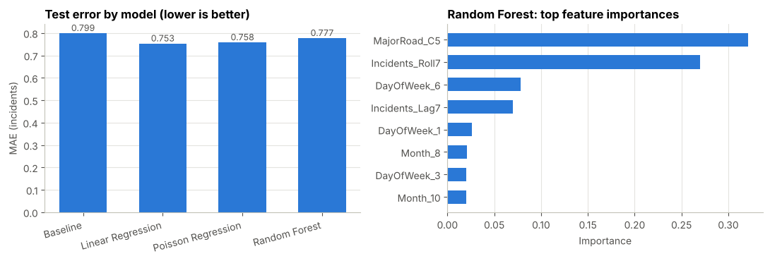
Figure 6.1 – Test error by model (left) and the features the Random Forest relies on most (right).
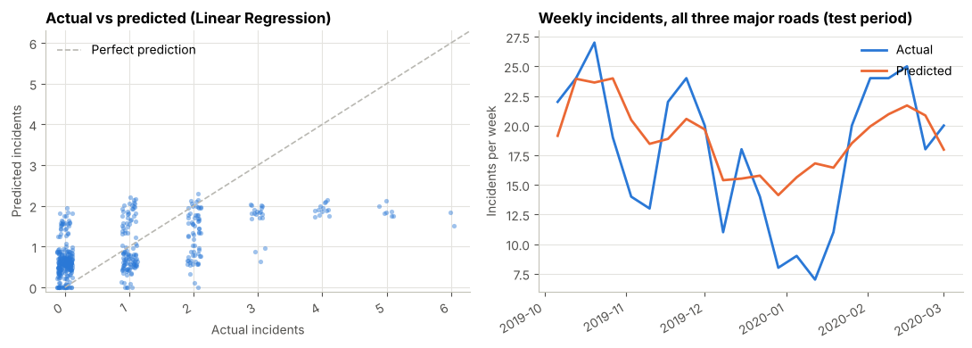
Figure 6.2 – Actual against predicted incidents (left) and weekly totals over the test period (right).

6.2 What the results mean
Linear Regression lowers the MAE by about 6% (0.799 to 0.753), lowers the RMSE from 1.019 to 0.976 and raises R² from 0.27 to 0.33, so it is better than the per-road mean baseline, but by a small margin. Poisson Regression has the best RMSE and R² (0.962 and 0.353). The ranking depends on the metric: about half of the road-days are zero, and MAE is minimized by predicting the median (0 or 1 for most roads), so the per-road median baseline reaches the lowest MAE (0.689) but the worst RMSE (1.155) and R² (0.07), because it never expects a busy day. The models estimate the expected count, which is what planners need, and they are better on RMSE and R². The three models are close: cross-validation chose Linear Regression, but the differences are small enough that the choice does not change the conclusions.
The more complex Random Forest did not help and was weaker than the two linear models, which is plausible with only about 1,200 training rows. Most of the signal is simple: the Random Forest relies mainly on whether the road is C5 and on the previous 7-day average, followed by Sunday, which matches the patterns found in Chapter 4.

6.3 Where the model is weak
Major road | Test MAE (Linear Regression)
C5 | 1.137
Ortigas | 0.588
Marcos Highway | 0.533
The model never predicts more than about 2 incidents in a day, so it misses the busiest days, which have 4 to 7 incidents. It also misses sudden drops: in the quiet weeks around Christmas and New Year, actual counts fell to about 7 to 9 per week while the model predicted about 15. The error is largest on C5, which has the highest and most variable counts.

6.4 Is the model useful for the intended application?
Partly. It reliably tells planners which road is busiest and that weekdays are busier than Sundays, but that is much of what the per-road average already says, and it does not beat a per-road median on MAE. It does not predict individual busy days well. It is useful as a rough planning guide for where to focus resources, not as a precise forecast of how many incidents will occur on a given day.

6.5 Demonstration: predicting a road and a date
The notebook includes a demonstration cell in which the group picks a major road and a date in the test period, and the selected model (Linear Regression) returns its predicted count next to the baseline and the actual MMDA-reported count, followed by the next 7 days for the same road. For example, for C5 on Tuesday 15 October 2019 the model predicted 2.09 incidents, the baseline 1.60, and MMDA reported 4. Over the following week the predictions stayed between about 1.5 and 2.2 per day while actual counts ranged from 2 to 5, which shows the same behavior described in 6.3: the model follows the usual level but does not predict spikes.

Chapter 7 – Recommendations and Responsible Data Use
The model is not ready for practical use. It is a reasonable starting point for planning, but it needs more data, validation with the MMDA and Pasig City's traffic management office, and a clear human decision-maker before anything depends on it.

7.1 How the results could help stakeholders
C5 should be the first priority when placing enforcers and tow trucks, because it averages 1.64 incidents per day, about three times Ortigas (0.54) and Marcos Highway (0.43). Incidents are lower on Sundays and highest around Tuesday on C5, so weekly schedules can put more units on weekdays. Reports are also highest from about 6 to 11 am, so morning coverage is where extra units matter most.
The model's predicted count per road can serve as a quick baseline expectation of how busy a day is likely to be, to be adjusted by staff who know about events and road works.

7.2 Additional data and validation needed
The model predicts one day ahead, because its features use the previous days' actual counts. To plan a week ahead, as the traffic office would when scheduling, the features would have to be rebuilt with a longer lead (for example, using only information at least 7 days old) and the model re-tested. More data is also needed: incident records beyond what MMDA tweets, the 187 rows without a city, and a longer period that includes 2021 onward, so the model can be tested after the pandemic period. More features would also help, such as holidays and school calendars (the model missed the quiet holiday weeks), rainfall and weather, traffic volume, and scheduled road works or events.
For validation, the predictions should be compared with MMDA's and the city's own incident records and tested on later periods. The stakeholders should be asked what level of error is acceptable, and the model should be tried in a small pilot before anyone relies on it.

7.3 Limitations
Dataset
The dataset holds only incidents that MMDA chose to tweet, and its author notes that it does not represent all incidents in Metro Manila. Because MMDA's jurisdiction is mainly the national roads, the data is biased toward roads such as EDSA and C5, and roads and times that MMDA monitors more closely look busier. The tweets were parsed automatically by a script, so some fields, such as times and locations, contain parsing errors. Many rows have no city, including many on Marcos Highway, so that road's counts are probably too low. Only about 18 months before March 2020 are used, because the author reports a collection gap in early 2020 and traffic also fell during the lockdown. Seventy-four incidents on other roads were left out. Days with no record were treated as days with no incident, which may not always be true, and the coordinates are location-level (about 100 distinct points), not exact positions.
Model
The model explains only about one third of the variation in daily counts (R² about 0.33), and it never predicts more than about 2 incidents in a day, so it misses the busiest days. It is a one-day-ahead model, and it does not beat a per-road median baseline on MAE (0.753 against 0.689), only on RMSE and R². It does not give an estimate of its own uncertainty, and because it was trained on one period it may not hold when traffic patterns change.

7.4 Data privacy, consent, fairness and responsible AI
On privacy and consent, the data is public information from a government agency and contains no names, plate numbers or other personal details, only vehicle types and places. No individual consent was needed, and the source is cited.
On fairness, a road with few reported incidents is not necessarily safer, because reporting depends on where and when MMDA posts. The results should not be used to blame drivers, neighborhoods or particular vehicle types.
On transparency and human oversight, the model's inputs, weaknesses and errors are documented here and, in the notebook, so decision-makers can judge how far to trust it. Any use should keep a person responsible for deciding where to deploy resources; the model informs the decision and does not make it.

7.5 Is the model ready for practical use?
No. The improvement over a simple per-road average is modest (MAE 0.753 against 0.799, RMSE 0.976 against 1.019), it does not beat a per-road median on MAE (0.689), the model misses busy days and holiday dips, and it was tested on only five months. It needs the additional data and validation in 7.2, and a pilot with the traffic office, before it should support real deployment decisions.

References
Data
Brotoisworo, P. (n.d.). Manila Traffic Incident Data: Incidents Reported by the Metro Manila Development Authority Twitter Page [Data set]. Kaggle. https://www.kaggle.com/datasets/esparko/mmda-traffic-incident-data. Licensed under CC BY-NC-SA 4.0. The original alerts are from the Metro Manila Development Authority (@MMDA) on Twitter/X.
Problem validation sources
Sigales, J. (2025, June 27). Most Metro Manila road crashes in 2024 took place on Edsa, C5 — MMDA. INQUIRER.net. https://newsinfo.inquirer.net/2075306/most-metro-manila-road-crashes-in-2024-took-place-on-edsa-c5-mmda
Wheels.ph. (2019, June 2). MMDA: PH lost P3.5-B per day to traffic in 2018. Philstar Wheels. https://wheels.ph/first-look/2019/06/02/6310/mmda-ph-lost-p3-5-b-per-day-to-traffic-in-2018/
Chua, P. (2020, February 26). For the third year running, C5 is Metro Manila's deadliest road. Top Gear Philippines. https://www.topgear.com.ph/news/motoring-news/deadliest-road-c5-metro-manila-sa3557-20200226-src-esquireph (originally published in Esquire Philippines; figures from the MMDA's 2019 MMARAS report).
Top Gear Philippines. (2020, February 24). MMDA reports an all-time high of 121,771 road accidents in 2019. https://www.topgear.com.ph/news/motoring-news/mmda-mmaras-2019-report-a4354-20200224
Tools and libraries (versions used when the notebook was run)
The notebook was run with Python 3.13.17, pandas 3.0.5, NumPy 2.5.3, scikit-learn 1.9.1 and Matplotlib 3.11.2.

